IT8303

AI Human Interface
  - Lab 4
Convolutional Neural Network (CNN)
What you will learn / do in this lab
- Implement a simple Neural Network (NN)
- Implement a Convolutional Neural Network (CNN)

TAble of
Contents
1. Overview 1
Introduction CNN 1
Applications of CNN 1
2. Simple NN 2
MNIST problem 2
Data Preparation 3
Training and evaluation of model 4
3. CNN Model 7
Data Preparation 7
CNN training and Evaluation 7

1.
Overview
In this practical we will use Python with PyTorch to implement Convolutional Neural Networks (CNN). A popular demonstration of the capability of deep learning techniques is object recognition in image data.

Introduction CNN
A CNN consists of an input and an output layer, as well as multiple hidden layers. The hidden layers of a CNN typically consist of convolutional layers, pooling layers, fully connected layers and normalization layers.

CNN are able to handle image data or any data where there information in neighboring regions are more important that those further away.

Applications of CNN
Applications of CNN includes:
- Image Recognition
- Video Analysis

2.
Simple NN
In this section we will implement a simple NN model for the MNIST problem.

MNIST problem
The MNIST problem is a dataset developed by Yann LeCun, Corinna Cortes and Christopher Burges for evaluating machine learning models on the handwritten digit classification problem.

The dataset was constructed from a number of scanned document dataset available from the National Institute of Standards and Technology (NIST). This is where the name for the dataset comes from, as the Modified NIST or MNIST dataset.

Images of digits were taken from a variety of scanned documents, normalized in size and centered. This makes it an excellent dataset for evaluating models, allowing the developer to focus on the machine learning with very little data cleaning or preparation required.

Each image is a 28 by 28 pixel square (784 pixels total). A standard spit of the dataset is used to evaluate and compare models, where 60,000 images are used to train a model and a separate set of 10,000 images are used to test it.

It is a digit recognition task. As such there are 10 digits (0 to 9) or 10 classes to predict. Results are reported using prediction error, which is nothing more than the inverted classification accuracy.

Excellent results achieve a prediction error of less than 1%.

Data Preparation
The PyTorch deep learning library provides a convenience method for loading the MNIST dataset. The dataset is downloaded automatically the first time this function is called and is stored in your specified folder.
This is very handy for developing and testing deep learning models.

# Transform: Convert into tensor and normalize
transform = transforms.Compose([
transforms.ToTensor(),
transforms.Normalize((0.5,), (0.5,))
])

# Download and load training/test data
train_data = datasets.MNIST(root='./data', train=True, download=True, transform=transform)
# Sample 10 training images
sample_indices = [0, 1, 2, 3, 4, 5, 6, 7, 8, 9] # Change these to see other examples
sample_images, sample_labels = zip(*[train_data[i] for i in sample_indices])
# Visualize the 10 sample images in a 2x5 grid
plt.figure(figsize=(10, 4))
for i in range(10):
plt.subplot(2, 5, i + 1)
plt.imshow(sample_images[i].squeeze(), cmap='gray')
plt.title(f'Label: {sample_labels[i]}')
plt.axis('off')
plt.show()

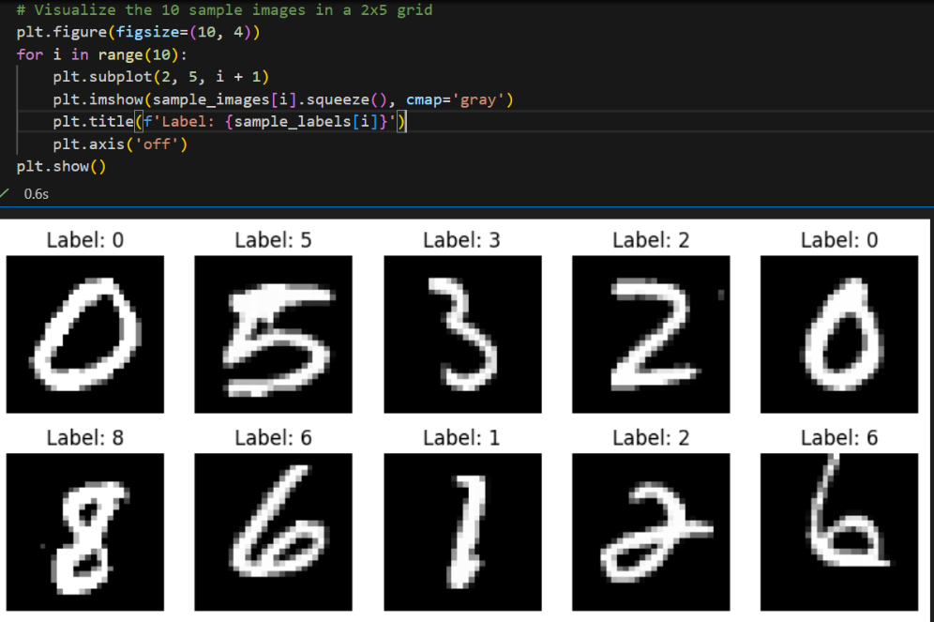

Training and evaluation of model

You can get very good results using a very simple neural network model with a single hidden layer. In this section we will create a simple multi-layer perceptron model. We will use this as a baseline for comparing more complex convolutional neural network models.

Initialize the random number generator seed to a constant to ensure that the results of your script are reproducible.

The training dataset is structured as a 3-dimensional array of instance, image width and image height. For a multi-layer perceptron model we must reduce the images down into a vector of pixels. In this case the 28×28 sized images will be 784 pixel input values.

We can do this transform easily using the nn.Flatten() layer of PyTorch.

The pixel values are gray scale between 0 and 255. It is almost always a good idea to perform some scaling of input values when using neural network models. Because the scale is well known and well behaved, we can very quickly normalize the pixel values to the range 0 and 1 by dividing each value by the maximum of 255. This step was done as part of the data loading step in the code above when we call transforms.ToTensor().

Finally, the output variable is an integer from 0 to 9. This is a multi-class classification problem. As such, it is good practice to use a one hot encoding of the class values, transforming the vector of class integers into a binary matrix. Again, PyTorch simplifies this step by doing that automatically inside the criterion function nn.CrossEntropyLoss().

The model is a simple neural network with one hidden layer with the same number of neurons as there are inputs (784). A rectifier activation function is used for the neurons in the hidden layer.

A softmax activation function is used on the output layer to turn the outputs into probability-like values and allow one class of the 10 to be selected as the model’s output prediction, and then the loss is calculated by comparing the model’s output with the actual label. These two steps are combined in PyTorch via the nn.CrossEntropyLoss() criterion function. It is also equivalent to using nn.Softmax(dim=1) layer followed by using nn.NLLLoss().

The efficient ADAM (adaptive momentum) gradient descent algorithm is used to learn the weights.

The model is fit over 3 epochs with updates every 64 images (batch size in the data loading process). We also split the train data into two sets, the smaller one for validation.

Finally, the test dataset is used to evaluate the model and a classification error rate is printed.

# Split into training and validation sets
train_data = datasets.MNIST(root='./data', train=True, download=True, transform=transform)
train_data, val_data = torch.utils.data.random_split(train_data, [50000, 10000])
train_loader = DataLoader(train_data, batch_size=64, shuffle=True)
val_loader = DataLoader(val_data, batch_size=64, shuffle=False)

# Load test data
test_data = datasets.MNIST(root='./data', train=False, download=True, transform=transform)
test_loader = DataLoader(test_data, batch_size=64, shuffle=False)

# Metrics
def get_accuracy(outputs, labels):
_, predictions = torch.max(outputs, 1)
correct = (predictions == labels).sum().item()
return correct / len(labels)

# Define a simple feedforward neural network
linear_model = nn.Sequential(
nn.Flatten(), # Converts (1, 28, 28) to (784)
nn.Linear(784, 128), # Input layer to hidden layer
nn.ReLU(), # Activation function
nn.Linear(128, 64), # Second hidden layer
nn.ReLU(),
nn.Linear(64, 10), # Output layer (10 classes for digits 0-9)
)

# Train the model
linear_model.train() # Set model to training mode
optimizer = torch.optim.Adam(linear_model.parameters(), lr=0.001)
criterion = nn.CrossEntropyLoss()

# Variables to store loss and accuracy history
train_loss_history = []
val_loss_history = []
train_acc_history = []
val_acc_history = []

# Train the model for a few epochs, storing the loss and accuracy in training and validation sets
epochs = 3
for epoch in range(epochs):
train_loss = 0
train_acc = 0
start_time = time.time()
for images, labels in train_loader:
optimizer.zero_grad() # Reset gradients
output = linear_model(images) # Forward pass
loss = criterion(output, labels) # Calculate loss
loss.backward() # Backward pass
optimizer.step() # Update weights
train_loss += loss.item()
train_acc += get_accuracy(output, labels)
end_time = time.time()
# Track loss and accuracy for training and validation set
train_loss_history.append(train_loss / len(train_loader))
train_acc_history.append(train_acc / len(train_loader))

# Validate the model
with torch.no_grad():
val_loss = 0
val_acc = 0
for val_images, val_labels in val_loader:
val_output = linear_model(val_images)
val_loss += criterion(val_output, val_labels).item()
val_acc += get_accuracy(val_output, val_labels)
val_loss_history.append(val_loss / len(val_loader))
val_acc_history.append(val_acc / len(val_loader))

print(f"Epoch {epoch+1} done in {end_time - start_time:.2f} seconds. Train Loss: {train_loss_history[-1]:.4f}, Train Acc: {train_acc_history[-1]:.4f}, Val Loss: {val_loss_history[-1]:.4f}, Val Acc: {val_acc_history[-1]:.4f}")

# Test the model on the test set
linear_model.eval() # Set model to evaluation mode
test_loss = 0
test_acc = 0
with torch.no_grad():
for test_images, test_labels in test_loader:
test_output = linear_model(test_images)
test_loss += criterion(test_output, test_labels).item()
test_acc += get_accuracy(test_output, test_labels)
print(f"Test Loss: {test_loss / len(test_loader):.4f}, Test Acc: {test_acc / len(test_loader):.4f}")

In my run, this gives 95.52% accuracy on the test set.

We can also print the training loss history:

# Plot training and validation loss/accuracy curves
plt.figure(figsize=(12, 4))

plt.subplot(1, 2, 1)
plt.plot(train_loss_history, label='Train Loss')
plt.plot(val_loss_history, label='Validation Loss')
plt.xlabel('Epoch')
plt.ylabel('Loss')
plt.legend()
plt.title('Training and Validation Loss')

plt.subplot(1, 2, 2)
plt.plot(train_acc_history, label='Train Accuracy')
plt.plot(val_acc_history, label='Validation Accuracy')
plt.xlabel('Epoch')
plt.ylabel('Accuracy')
plt.legend()
plt.title('Training and Validation Accuracy')

plt.tight_layout()
plt.show()
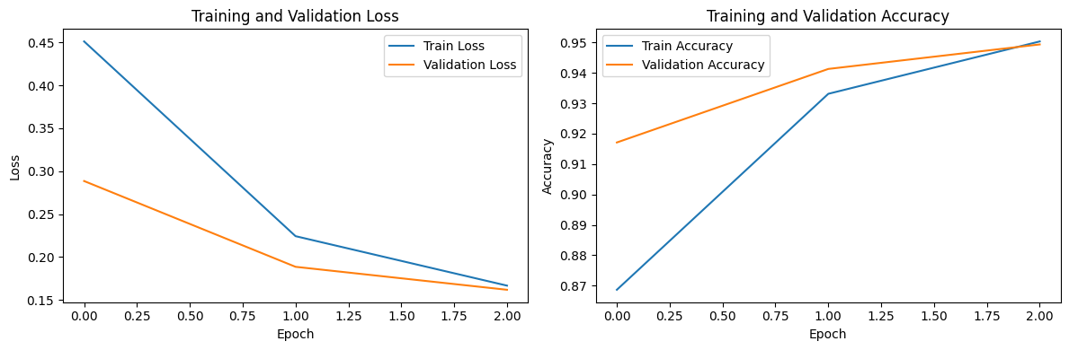
We see the loss decreasing for both training and validation. This is a sign we can still increase the number of epochs.

3.
CNN Model
In this section we will implement a more complex CNN model for the MNIST problem.

Data Preparation
We always initialize the random number generator to a constant seed value for reproducibility of results.

Next we need to load the MNIST dataset and reshape it so that it is suitable for use training a CNN. In PyTorch, the layers used for two-dimensional convolutions expect pixel values with the dimensions [pixels][width][height].

In the case of RGB, the first dimension pixels would be 3 for the red, green and blue components and it would be like having 3 image inputs for every color image. In the case of MNIST where the pixel values are gray scale, the pixel dimension is set to 1.

As before, behind the scene the transforms.ToTensor() function normalizes the pixel values to the range 0 and 1 and one hot encodes the output variables.

CNN training and Evaluation
Convolutional neural networks are more complex than standard multi-layer perceptrons, so we will start by using a simple structure to begin with that uses all of the elements for state of the art results. Below summarizes the network architecture.

- The first hidden layer is a convolutional layer called a Convolution2D. The layer has 32 feature maps, which with the size of 5×5 and a rectifier activation function. This is the input layer, expecting images with the structure outline above [pixels][width][height].
- Next we define a pooling layer that takes the max called MaxPooling2D. It is configured with a pool size of 2×2.
- The next layer is a regularization layer using dropout called Dropout. It is configured to randomly exclude 20% of neurons in the layer in order to reduce overfitting.
- Next is a layer that converts the 2D matrix data to a vector called Flatten. It allows the output to be processed by standard fully connected layers.
- Next a fully connected layer with 128 neurons and rectifier activation function.
- Finally, the output layer has 10 neurons for the 10 classes
- As before, the model is trained using Cross Entropy loss and the ADAM gradient descent algorithm.

We evaluate the model the same way as before with the multi-layer perceptron. The CNN is fit over 3 epochs with a batch size of 64.

Running the example, the accuracy on the training and validation test is printed each epoch and at the end of the classification error rate is printed.

In my run, the network achieves an accuracy of 98.58% on the test set, which is better than our simple multi-layer perceptron model above.

# Split into training and validation sets
train_data = datasets.MNIST(root='./data', train=True, download=True, transform=transform)
train_data, val_data = torch.utils.data.random_split(train_data, [50000, 10000])
train_loader = DataLoader(train_data, batch_size=64, shuffle=True)
val_loader = DataLoader(val_data, batch_size=64, shuffle=False)

# Load test data
test_data = datasets.MNIST(root='./data', train=False, download=True, transform=transform)
test_loader = DataLoader(test_data, batch_size=64, shuffle=False)

# Metrics
def get_accuracy(outputs, labels):
_, predictions = torch.max(outputs, 1)
correct = (predictions == labels).sum().item()
return correct / len(labels)

# Define a simple CNN model
cnn_model = nn.Sequential(
# First Block: (1, 28, 28) --conv--> (32, 24, 24) --maxpool--> (32, 12, 12)
nn.Conv2d(in_channels=1, out_channels=32, kernel_size=5),
nn.ReLU(),
nn.MaxPool2d(kernel_size=2),

# Classifier
nn.Dropout(0.2),
nn.Flatten(), # Flattens 32*12*12 into 128
nn.Linear(32*12*12, 128),
nn.ReLU(),
nn.Linear(128, 10) # 10 output classes
)
# Train CNN model
cnn_model.train() # Set model to training mode
optimizer = torch.optim.Adam(cnn_model.parameters(), lr=0.001)
criterion = nn.CrossEntropyLoss()

# Variables to store loss and accuracy history
cnn_train_loss_history = []
cnn_val_loss_history = []
cnn_train_acc_history = []
cnn_val_acc_history = []

# Train the model for a few epochs, storing the loss and accuracy in training and validation sets
epochs = 3
for epoch in range(epochs):
train_loss = 0
train_acc = 0
start_time = time.time()
for images, labels in train_loader:
optimizer.zero_grad() # Reset gradients
output = cnn_model(images) # Forward pass
loss = criterion(output, labels) # Calculate loss
loss.backward() # Backward pass
optimizer.step() # Update weights
train_loss += loss.item()
train_acc += get_accuracy(output, labels)
end_time = time.time()
# Track loss and accuracy for training and validation set
cnn_train_loss_history.append(train_loss / len(train_loader))
cnn_train_acc_history.append(train_acc / len(train_loader))

# Validate the model
with torch.no_grad():
val_loss = 0
val_acc = 0
for val_images, val_labels in val_loader:
val_output = cnn_model(val_images)
val_loss += criterion(val_output, val_labels).item()
val_acc += get_accuracy(val_output, val_labels)
cnn_val_loss_history.append(val_loss / len(val_loader))
cnn_val_acc_history.append(val_acc / len(val_loader))
print(f"Epoch {epoch+1} done in {end_time - start_time:.2f} seconds. Train Loss: {cnn_train_loss_history[-1]:.4f}, Train Acc: {cnn_train_acc_history[-1]:.4f}, Val Loss: {cnn_val_loss_history[-1]:.4f}, Val Acc: {cnn_val_acc_history[-1]:.4f}")

# Test the model on the test set
cnn_model.eval() # Set model to evaluation mode
test_loss = 0
test_acc = 0
with torch.no_grad():
for test_images, test_labels in test_loader:
test_output = cnn_model(test_images)
test_loss += criterion(test_output, test_labels).item()
test_acc += get_accuracy(test_output, test_labels)
print(f"Test Loss: {test_loss / len(test_loader):.4f}, Test Acc: {test_acc / len(test_loader):.4f}")

And as usual, we can also plot the history of the loss and accuracy.
# Plot training and validation loss/accuracy curves
plt.figure(figsize=(12, 4))

plt.subplot(1, 2, 1)
plt.plot(cnn_train_loss_history, label='Train Loss')
plt.plot(cnn_val_loss_history, label='Validation Loss')
plt.xlabel('Epoch')
plt.ylabel('Loss')
plt.legend()
plt.title('CNN Training and Validation Loss')

plt.subplot(1, 2, 2)
plt.plot(cnn_train_acc_history, label='Train Accuracy')
plt.plot(cnn_val_acc_history, label='Validation Accuracy')
plt.xlabel('Epoch')
plt.ylabel('Accuracy')
plt.legend()
plt.title('CNN Training and Validation Accuracy')

plt.tight_layout()
plt.show()
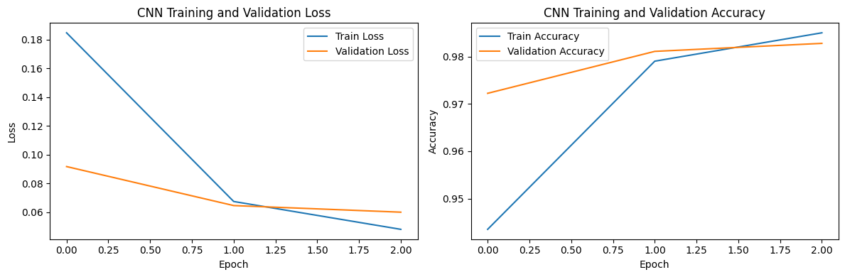
The validation loss seems to be stagnating, a sign that perhaps number of epochs is already close to optimal. Notice that CNN achieves the optimal weights in fewer epoch compared to the linear model. Typically, the closer the model is to the actual data distribution (in this case CNN to image data), the easier (and hence faster) it is to train the model.

More Complex CNN Model

Now that we have seen how to create a simple CNN, let’s take a look at a model capable of close to state of the art results.

This time we define a large CNN architecture with additional convolutional, max pooling layers and fully connected layers. The network topology can be summarized as follows.

- Convolutional layer with 30 feature maps of size 5×5.
- Pooling layer taking the max over 2*2 patches.
- Convolutional layer with 15 feature maps of size 3×3.
- Pooling layer taking the max over 2*2 patches.
- Dropout layer with a probability of 20%.
- Flatten layer.
- Fully connected layer with 128 neurons and rectifier activation.
- Fully connected layer with 50 neurons and rectifier activation.
- Output layer.

Running the example prints accuracy on the training and validation datasets each epoch and a final classification error rate.

Notice that the model takes longer to run per epoch. This slightly larger model achieves the respectable classification accuracy of 98.48% on the test set on my run. Notice how the performance isn’t exactly better than the normal CNN. This could be due to multiple reasons, the most common one being overfitting or underfitting. You can check this by checking the validation loss during training.

# Larger CNN Model
deep_cnn_model = nn.Sequential(
# First Block: (1, 28, 28) --conv--> (30, 24, 24) --maxpool--> (30, 12, 12)
nn.Conv2d(in_channels=1, out_channels=30, kernel_size=5),
nn.ReLU(),
nn.MaxPool2d(kernel_size=2),

# Second Block: (30, 12, 12) --conv--> (15, 10, 10) --maxpool--> (15, 5, 5)
nn.Conv2d(in_channels=30, out_channels=15, kernel_size=3),
nn.ReLU(),
nn.MaxPool2d(kernel_size=2),

# Classifier
nn.Dropout(0.2),
nn.Flatten(), # Flattens 15*5*5 into 128
nn.Linear(15*5*5, 128),
nn.ReLU(),
nn.Linear(128, 50),
nn.ReLU(),
nn.Linear(50, 10) # 10 output classes
)

# Train CNN model
deep_cnn_model.train() # Set model to training mode
optimizer = torch.optim.Adam(deep_cnn_model.parameters(), lr=0.001)
criterion = nn.CrossEntropyLoss()

# Variables to store loss and accuracy history
deep_cnn_train_loss_history = []
deep_cnn_val_loss_history = []
deep_cnn_train_acc_history = []
deep_cnn_val_acc_history = []

# Train the model for a few epochs, storing the loss and accuracy in training and validation sets
epochs = 3
for epoch in range(epochs):
train_loss = 0
train_acc = 0
start_time = time.time()
for images, labels in train_loader:
optimizer.zero_grad() # Reset gradients
output = deep_cnn_model(images) # Forward pass
loss = criterion(output, labels) # Calculate loss
loss.backward() # Backward pass
optimizer.step() # Update weights
train_loss += loss.item()
train_acc += get_accuracy(output, labels)
end_time = time.time()
# Track loss and accuracy for training and validation set
deep_cnn_train_loss_history.append(train_loss / len(train_loader))
deep_cnn_train_acc_history.append(train_acc / len(train_loader))

# Validate the model
with torch.no_grad():
val_loss = 0
val_acc = 0
for val_images, val_labels in val_loader:
val_output = deep_cnn_model(val_images)
val_loss += criterion(val_output, val_labels).item()
val_acc += get_accuracy(val_output, val_labels)
deep_cnn_val_loss_history.append(val_loss / len(val_loader))
deep_cnn_val_acc_history.append(val_acc / len(val_loader))
print(f"Epoch {epoch+1} done in {end_time - start_time:.2f} seconds. Train Loss: {deep_cnn_train_loss_history[-1]:.4f}, Train Acc: {deep_cnn_train_acc_history[-1]:.4f}, Val Loss: {deep_cnn_val_loss_history[-1]:.4f}, Val Acc: {deep_cnn_val_acc_history[-1]:.4f}")

# Test the model on the test set
deep_cnn_model.eval() # Set model to evaluation mode
test_loss = 0
test_acc = 0
with torch.no_grad():
for test_images, test_labels in test_loader:
test_output = deep_cnn_model(test_images)
test_loss += criterion(test_output, test_labels).item()
test_acc += get_accuracy(test_output, test_labels)
print(f"Test Loss: {test_loss / len(test_loader):.4f}, Test Acc: {test_acc / len(test_loader):.4f}")

Error Analysis
When we want to analyse the model, we can visualize the layers, similar to CNN Explainer example in lab 1. We can achieve that using the following code.
def visualize_feature_maps(model, loader):
# 1. Get a single batch of images
images, labels = next(iter(loader))
single_img = images[0:1] # Shape: [1, 1, 28, 28]

# 2. Extract the output to the intended layer (based on the info printed above)
# We use model.eval() to ensure consistent behavior
last_layer_idx = 0 # Index of the last layer we want to visualize
model.eval()
with torch.no_grad():
feature_maps = model[:last_layer_idx+1](single_img)

# 3. Plot the original image and several feature maps
fig, axes = plt.subplots(2, 4, figsize=(12, 6))

# Original Image
axes[0, 0].imshow(single_img[0, 0], cmap='gray')
axes[0, 0].set_title("Original Input")
axes[0, 0].axis('off')

# Feature Maps (first 7 filters)
for i in range(1, 8):
row, col = i // 4, i % 4
ax = axes[row, col]
# feature_maps shape: [1, 32, 24, 24]
ax.imshow(feature_maps[0, i-1].cpu(), cmap='RdBu_r') # Color map is red for negative and blue for positive activations
ax.set_title(f"Filter {i}")
ax.axis('off')

plt.tight_layout()
plt.show()

# Run visualization
visualize_feature_maps(cnn_model, train_loader)

It will print something like this:
